**Topology**

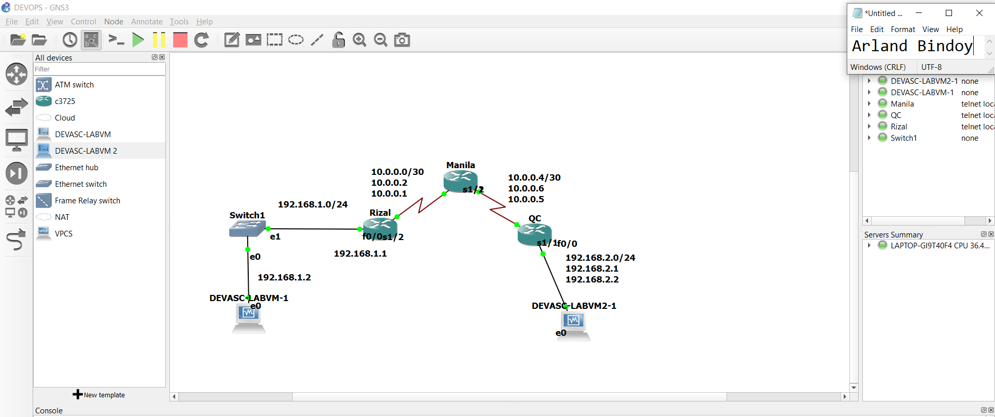

**Rizal Router Configuration**

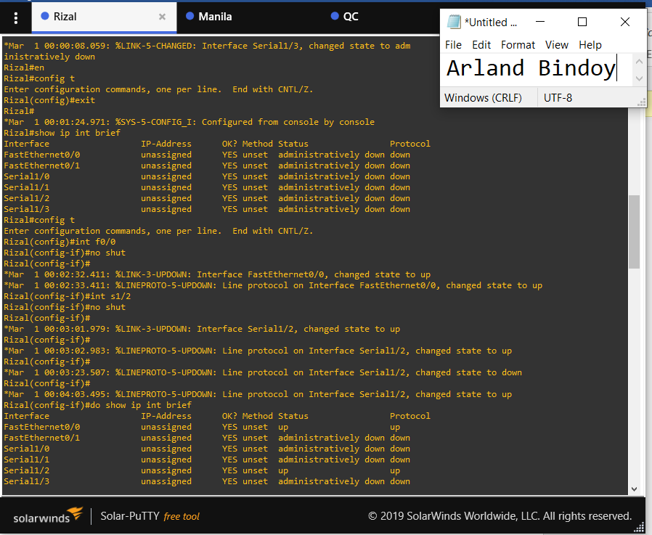

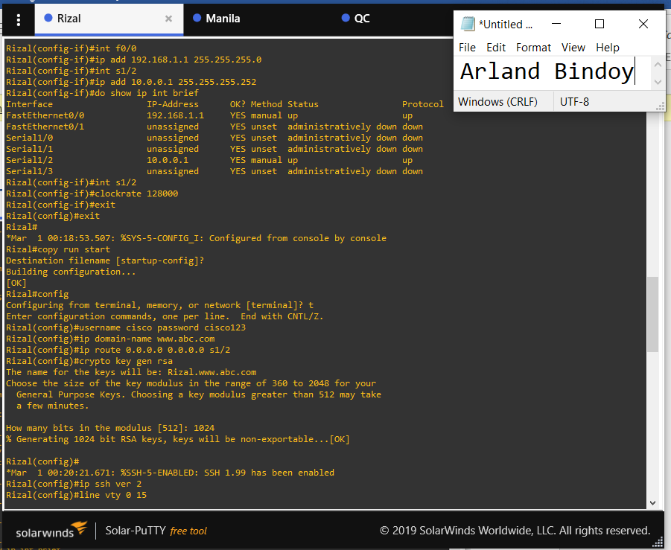

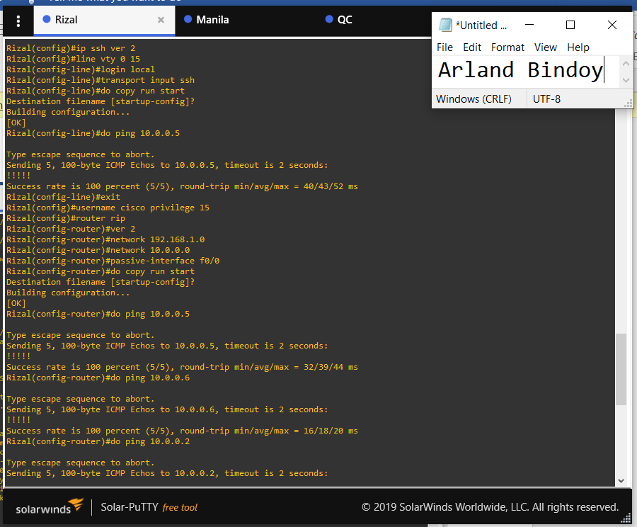

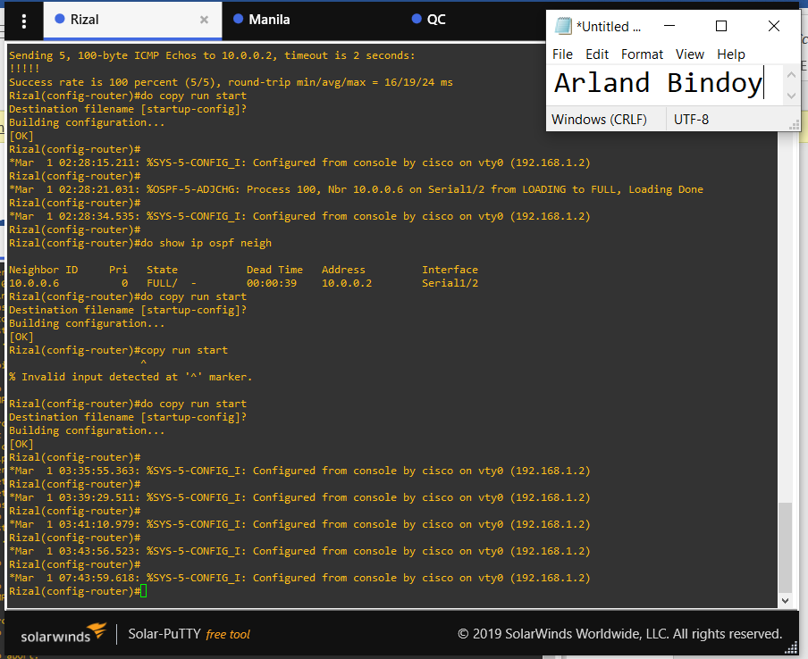

**Manila Router Configuration**

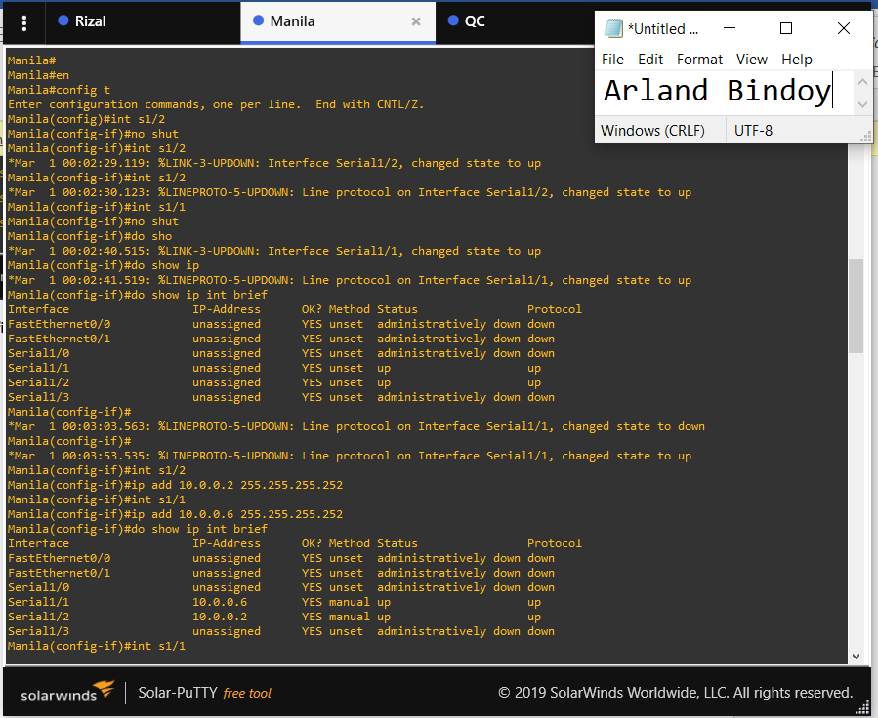

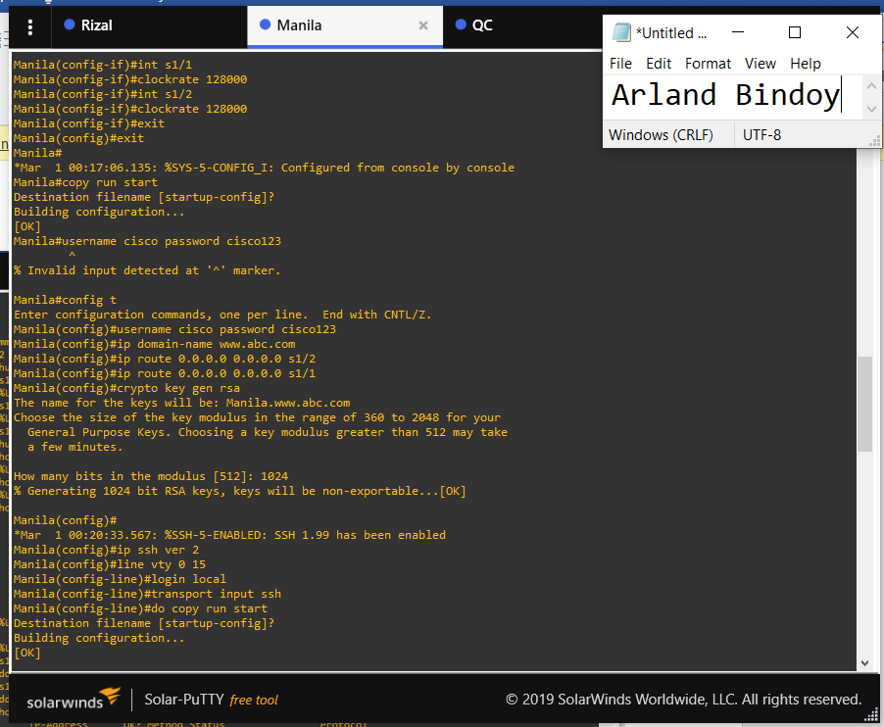

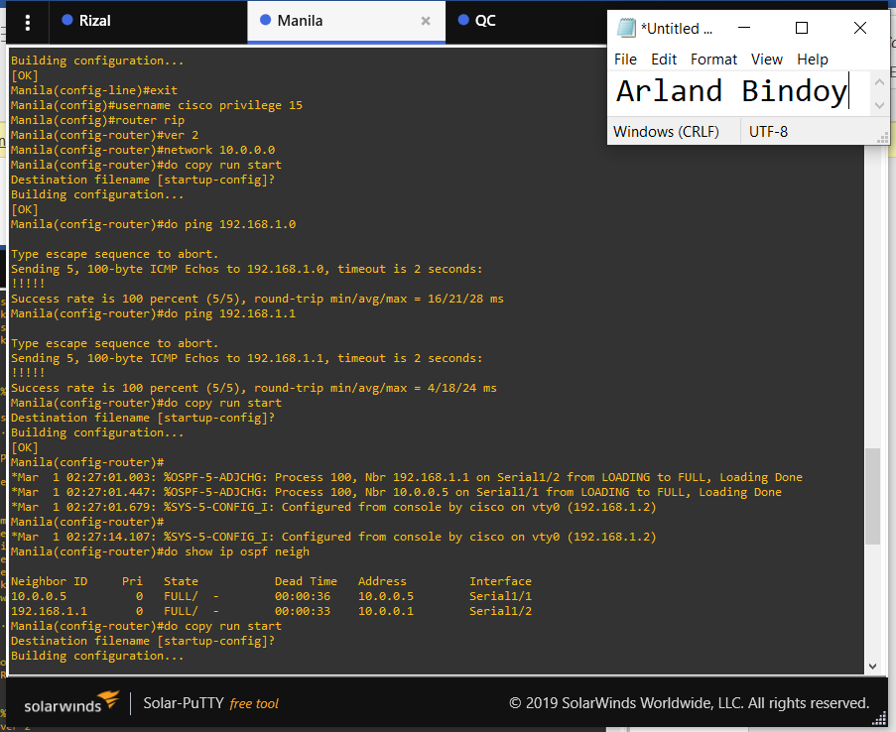

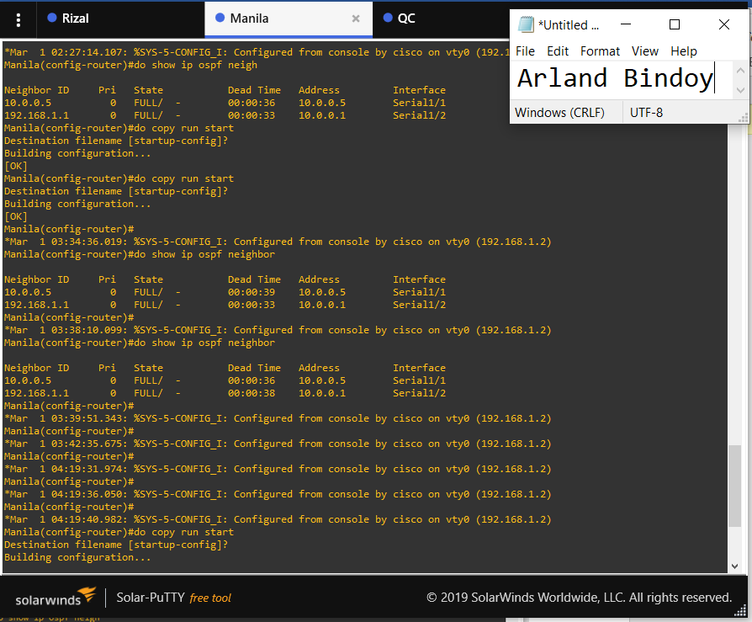

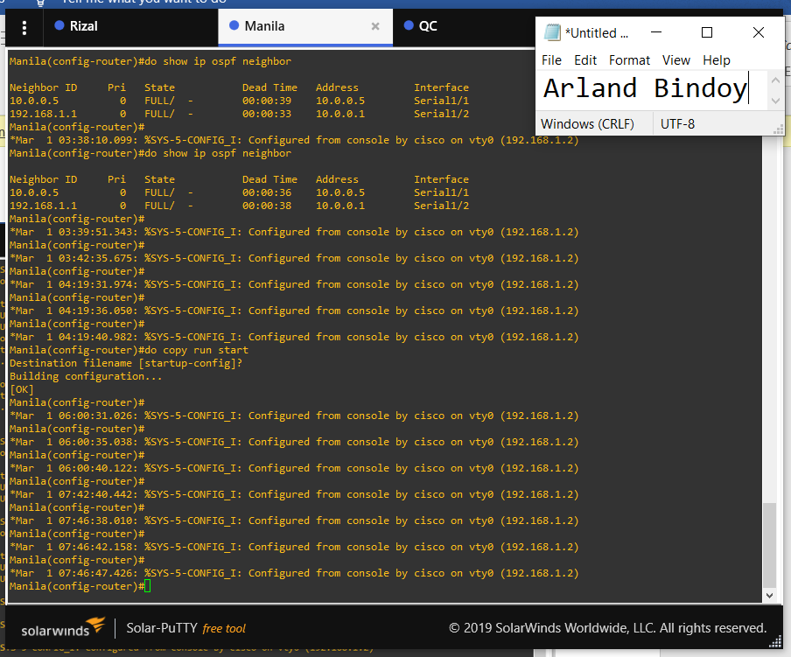

**QC Router Configuration**

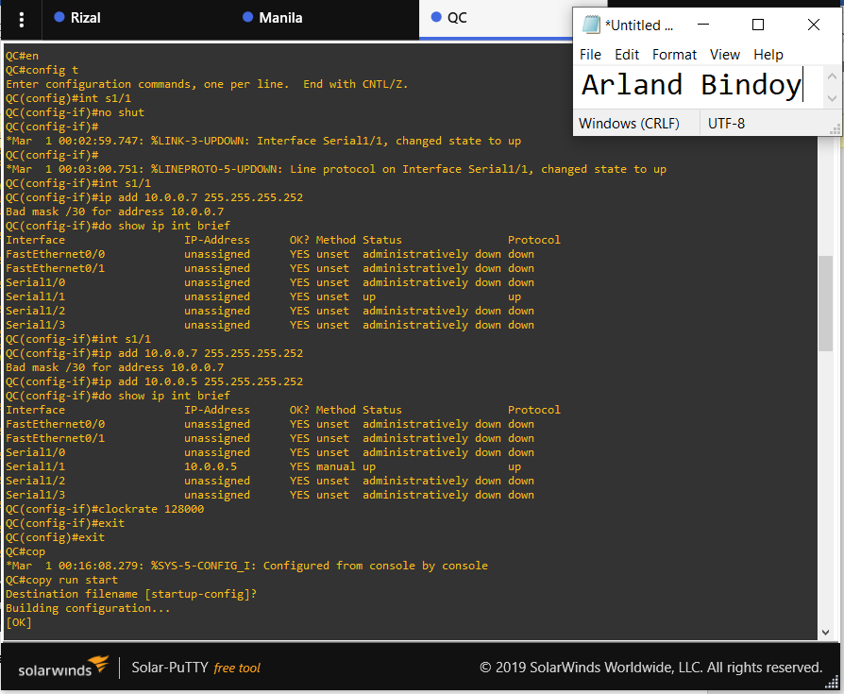

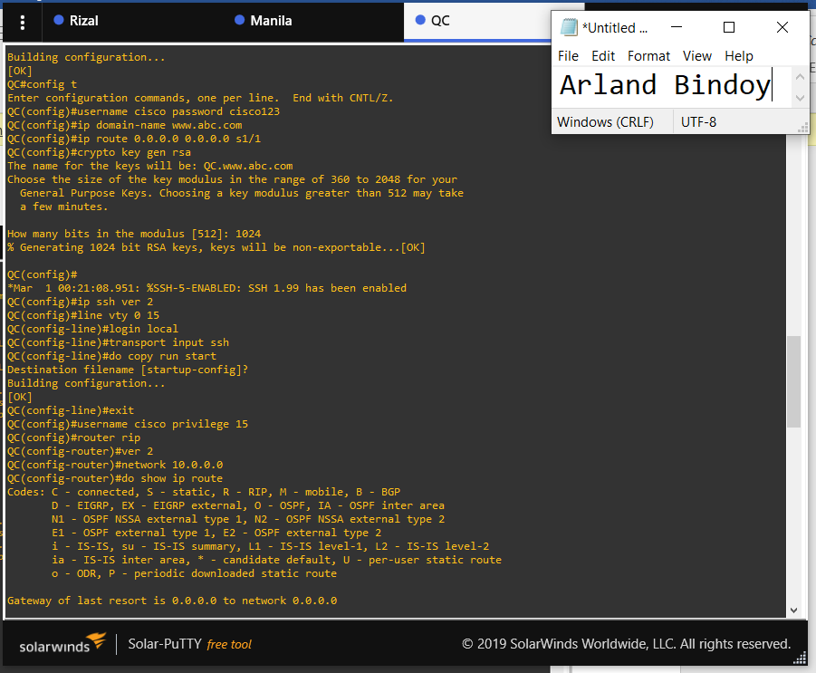

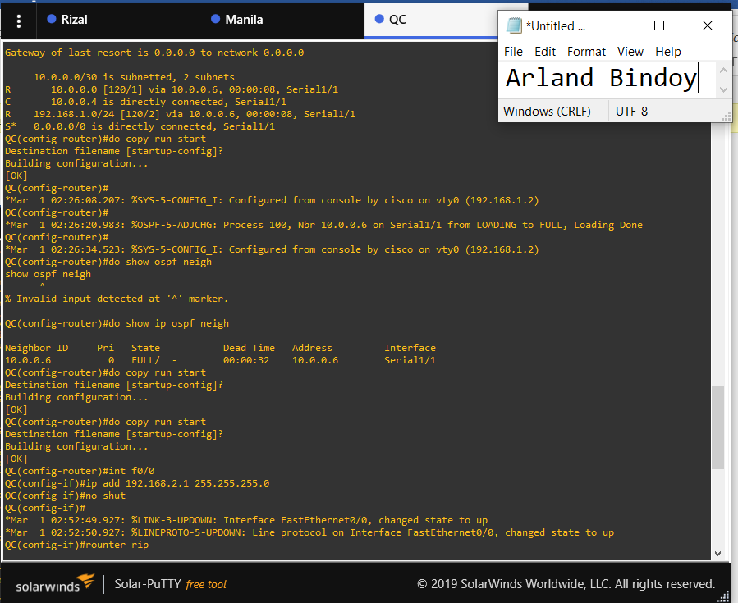

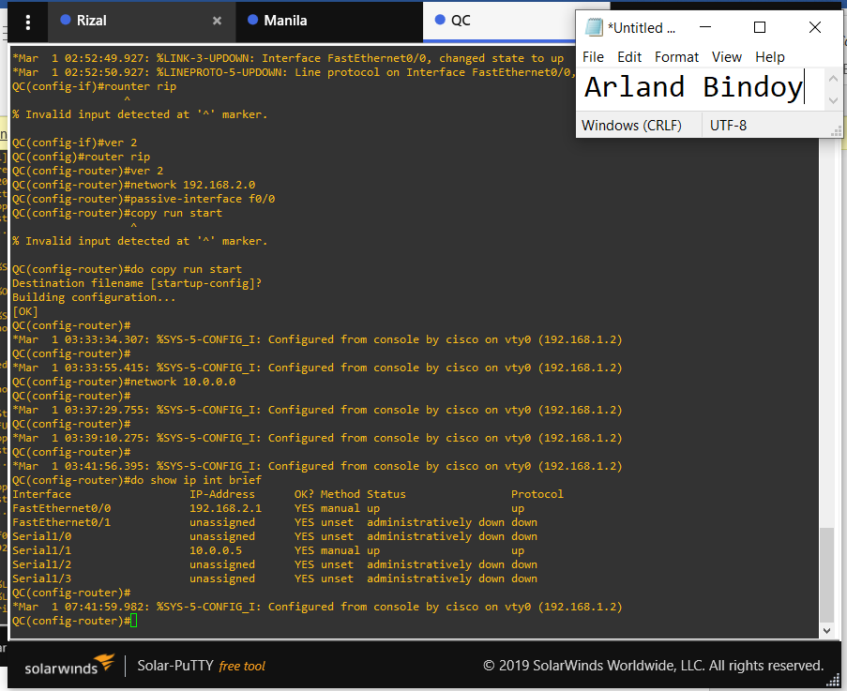

**Ansible.cfg**

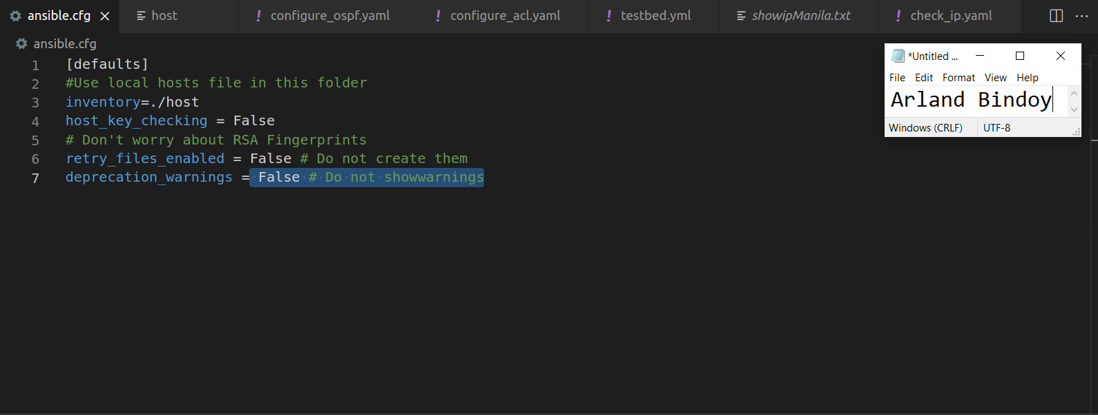

**host file**

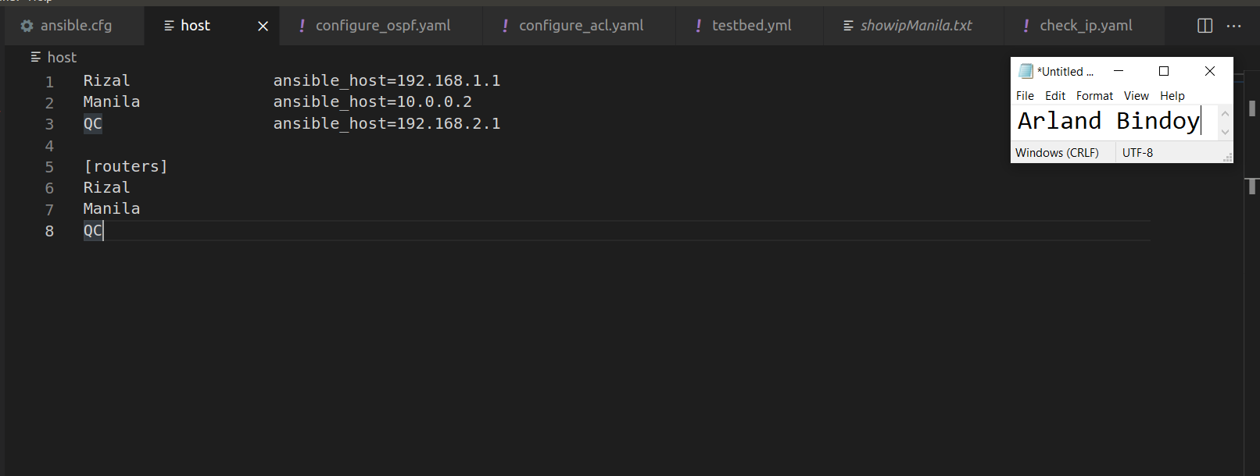

**check_ip.yaml**

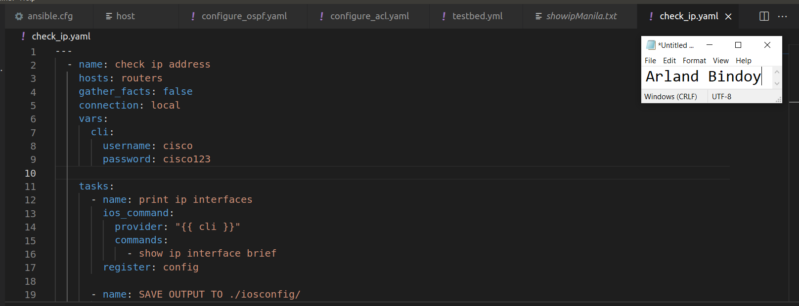

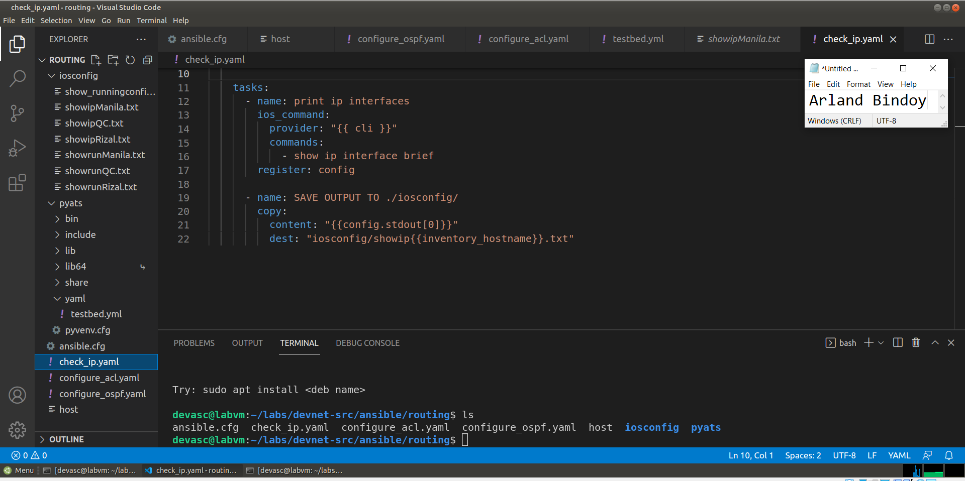

**Output of check_ip.yaml**

**showipRizal.txt**

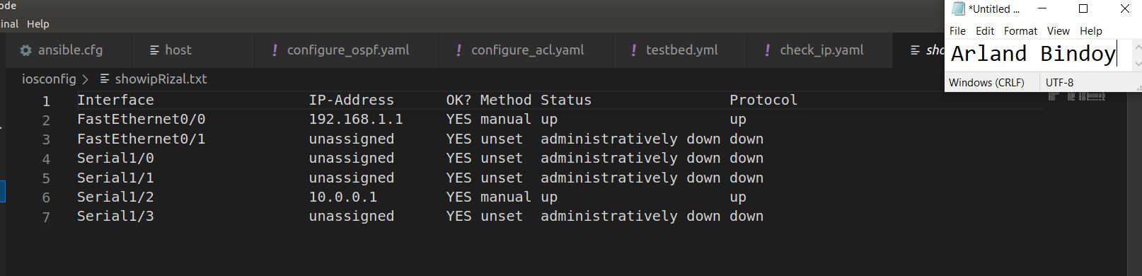

**showipManila.txt**

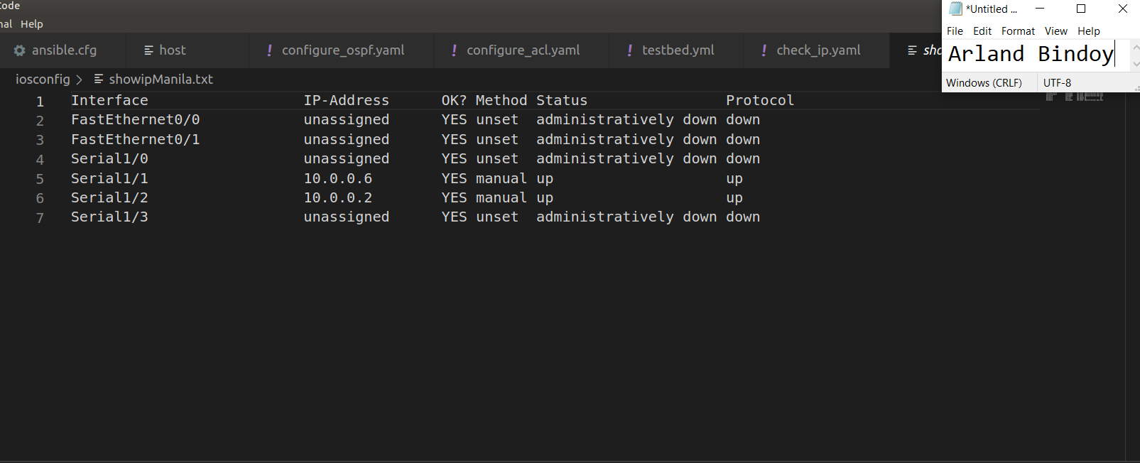

**showipQC.txt**

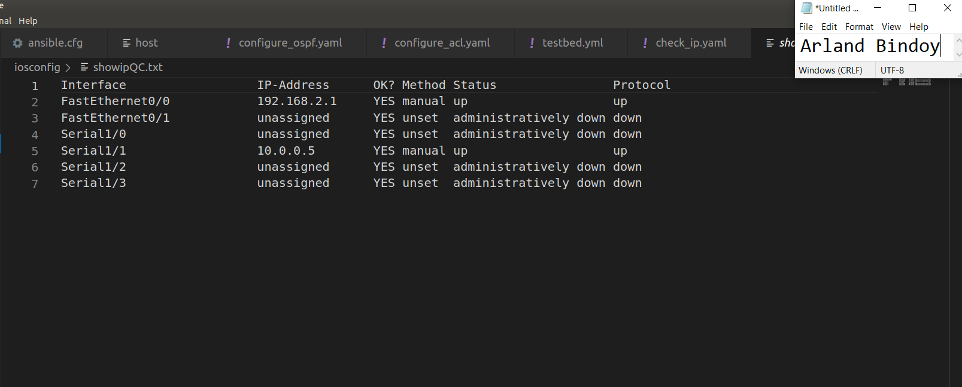

**configure_ospf.yaml**

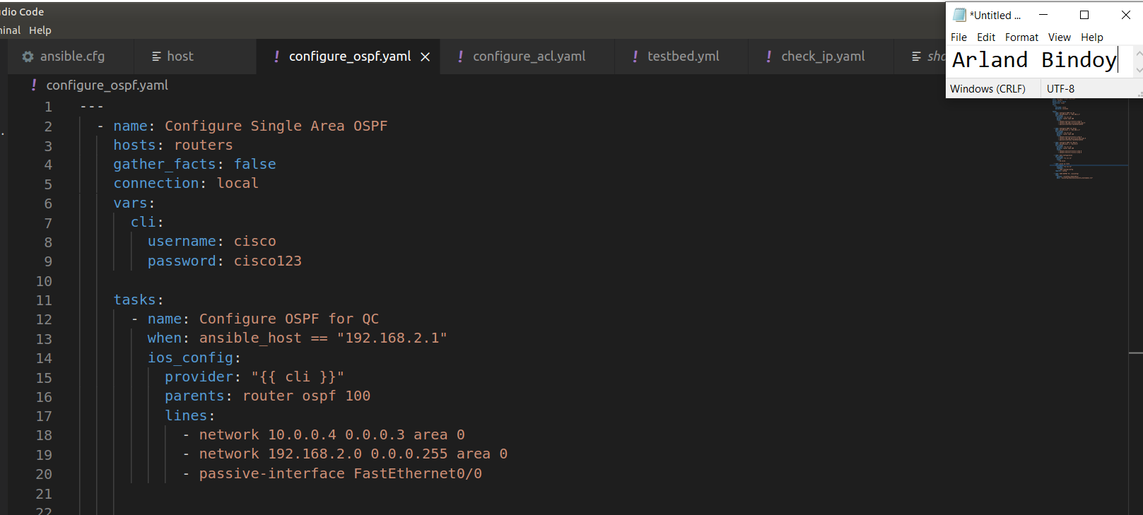

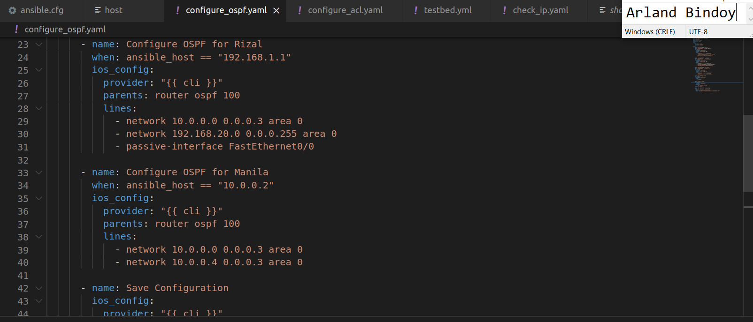

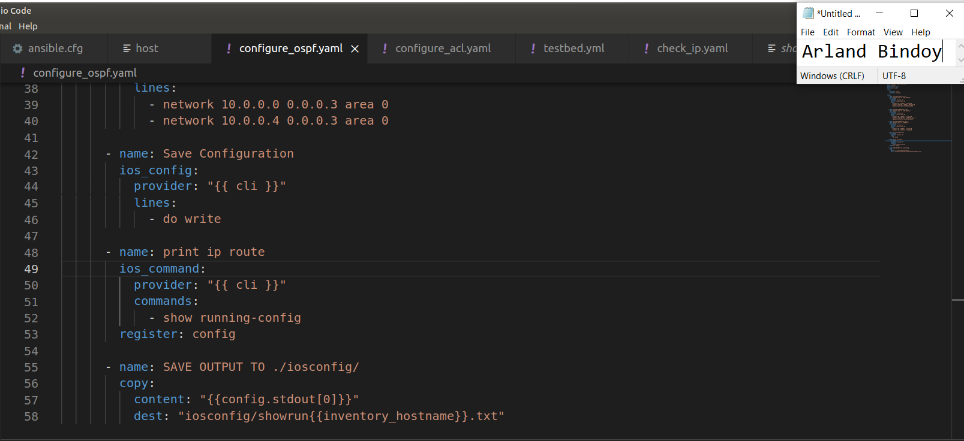

**Output of configure_ospf.yaml**

**showrunRIzal.txt**

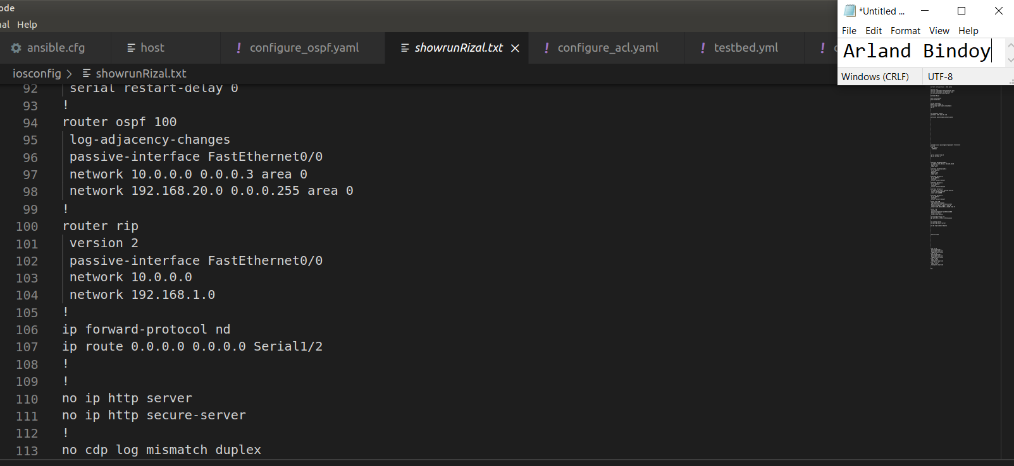

**showrunManila.txt**

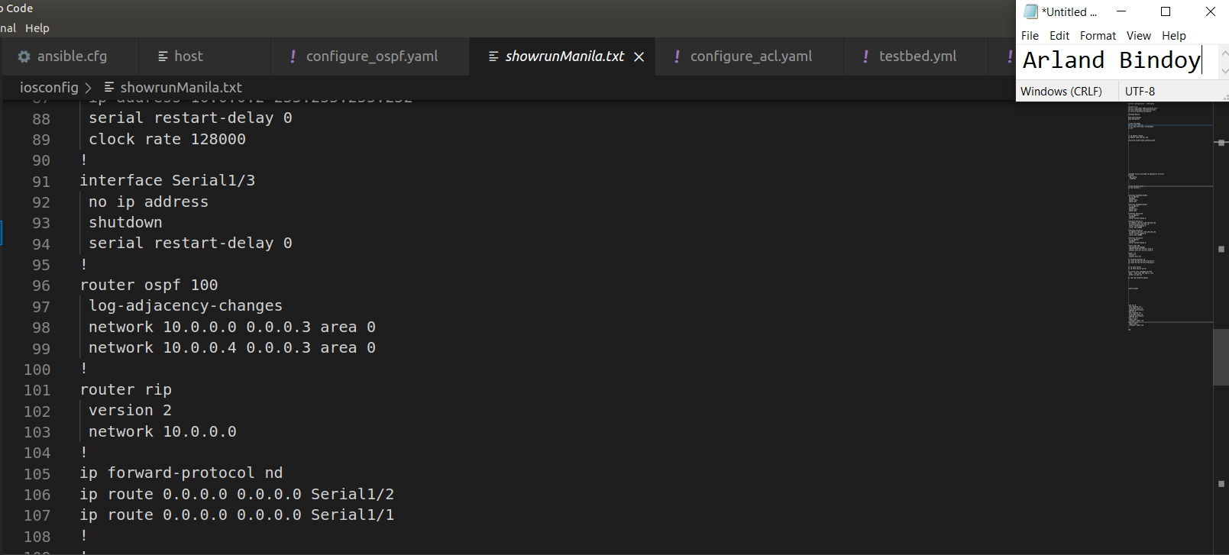

**showrunQC.txt**

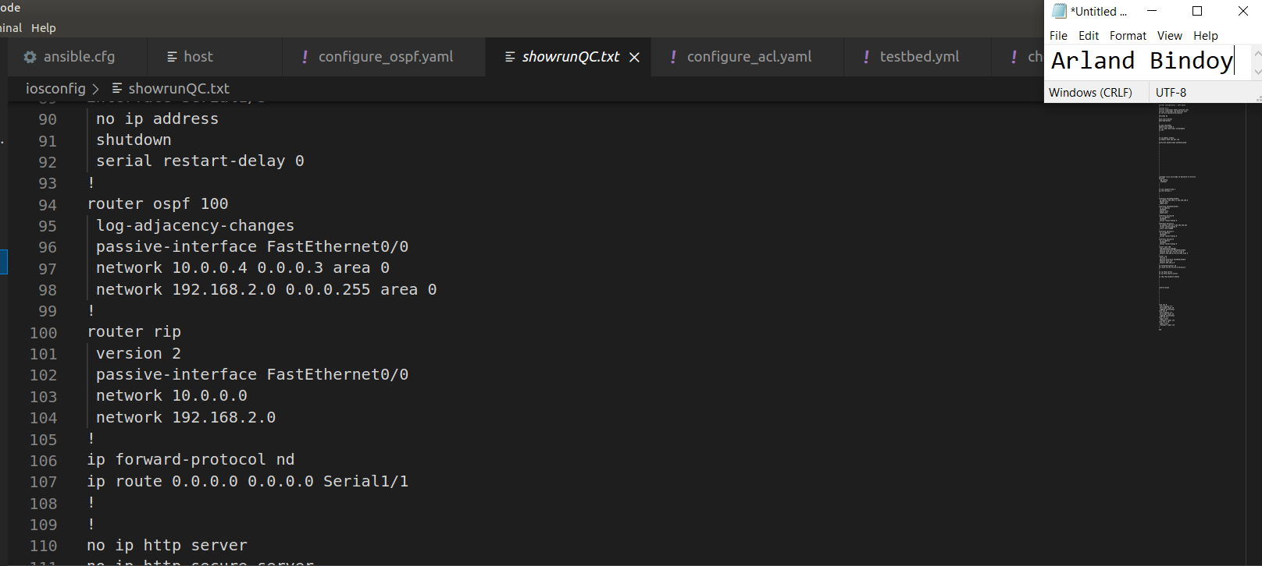

**Ping PC-LABVM to Rizal ip address 192.168.1.1**

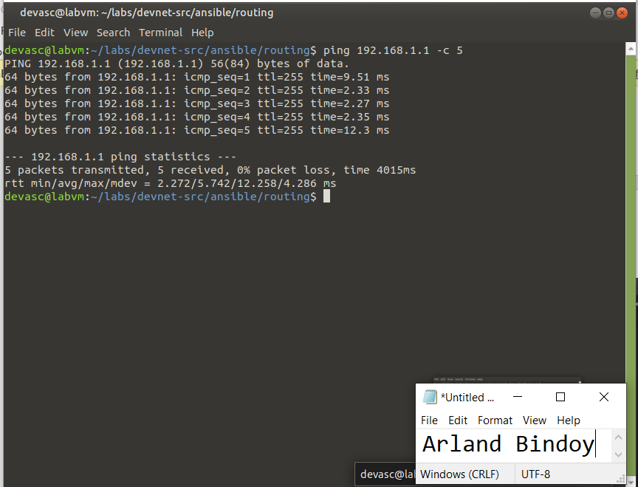

**Ping PC-LABVM to Rizal ip address 10.0.0.1**

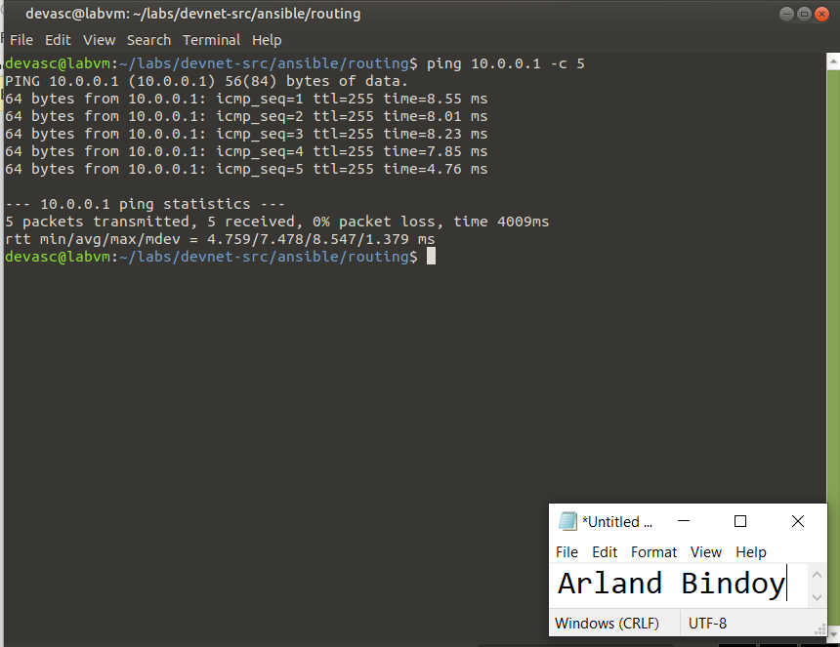

**Ping PC-LABVM to Manila ip address 10.0.0.2**

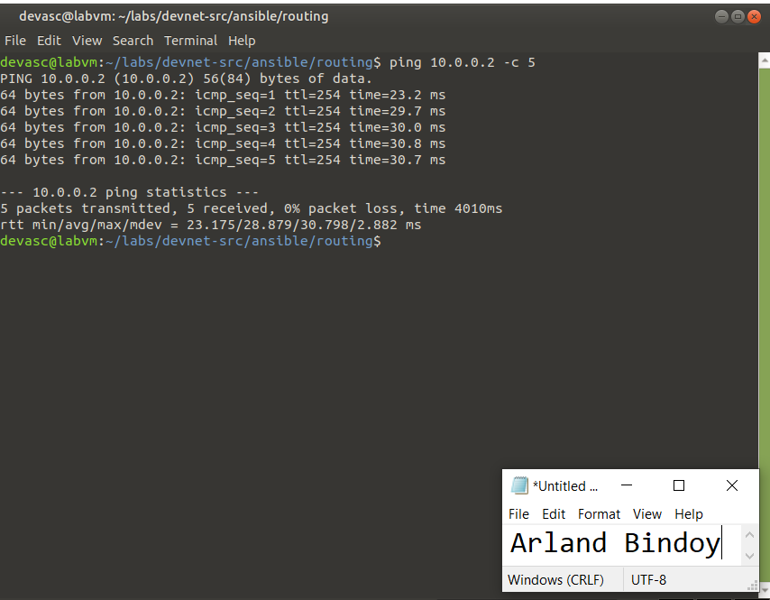

**Ping PC-LABVM to Manila ip address 10.0.0.6**

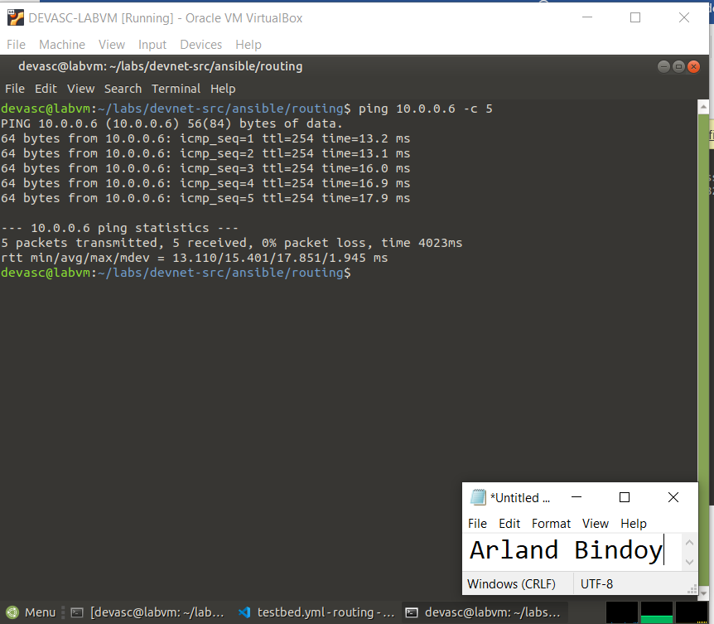

**Ping PC-LABVM to QC ip address 10.0.0.5**

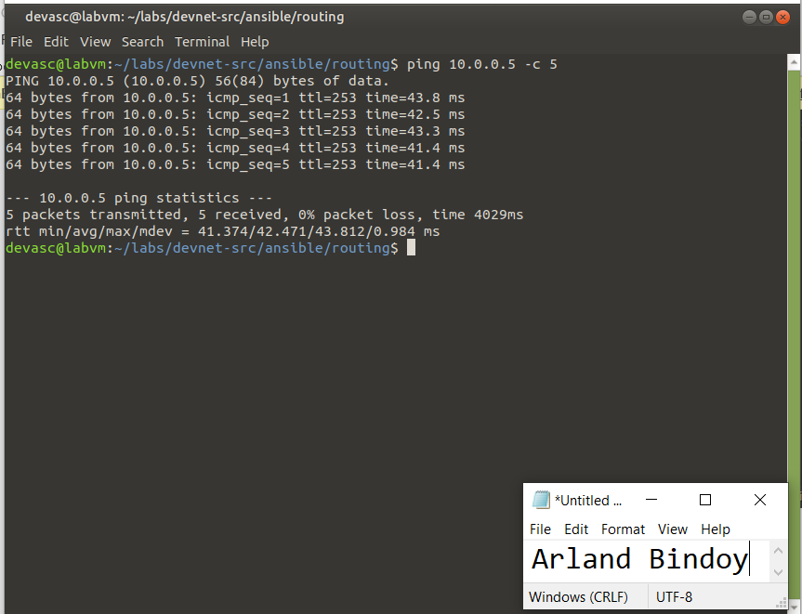

**Ping PC-LABVM to QC ip address 192.168.2.1**

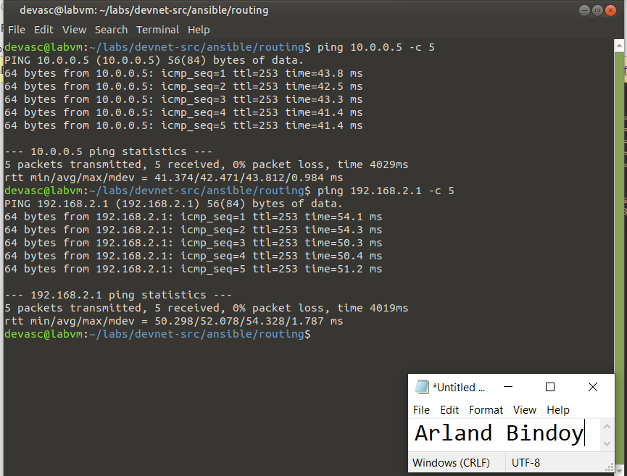

**configure_acl.yaml**

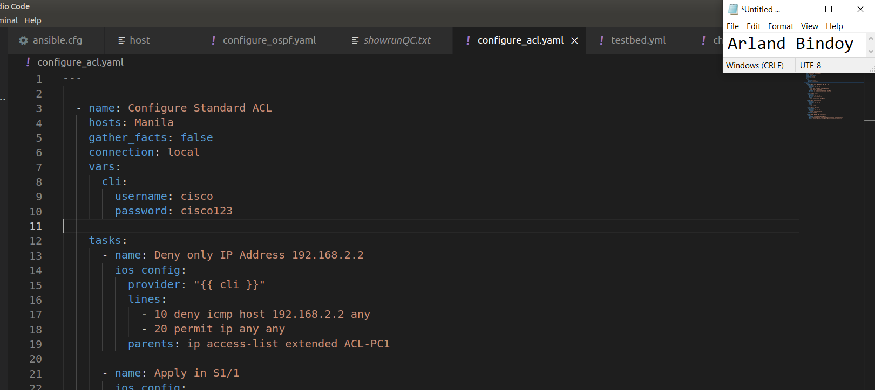

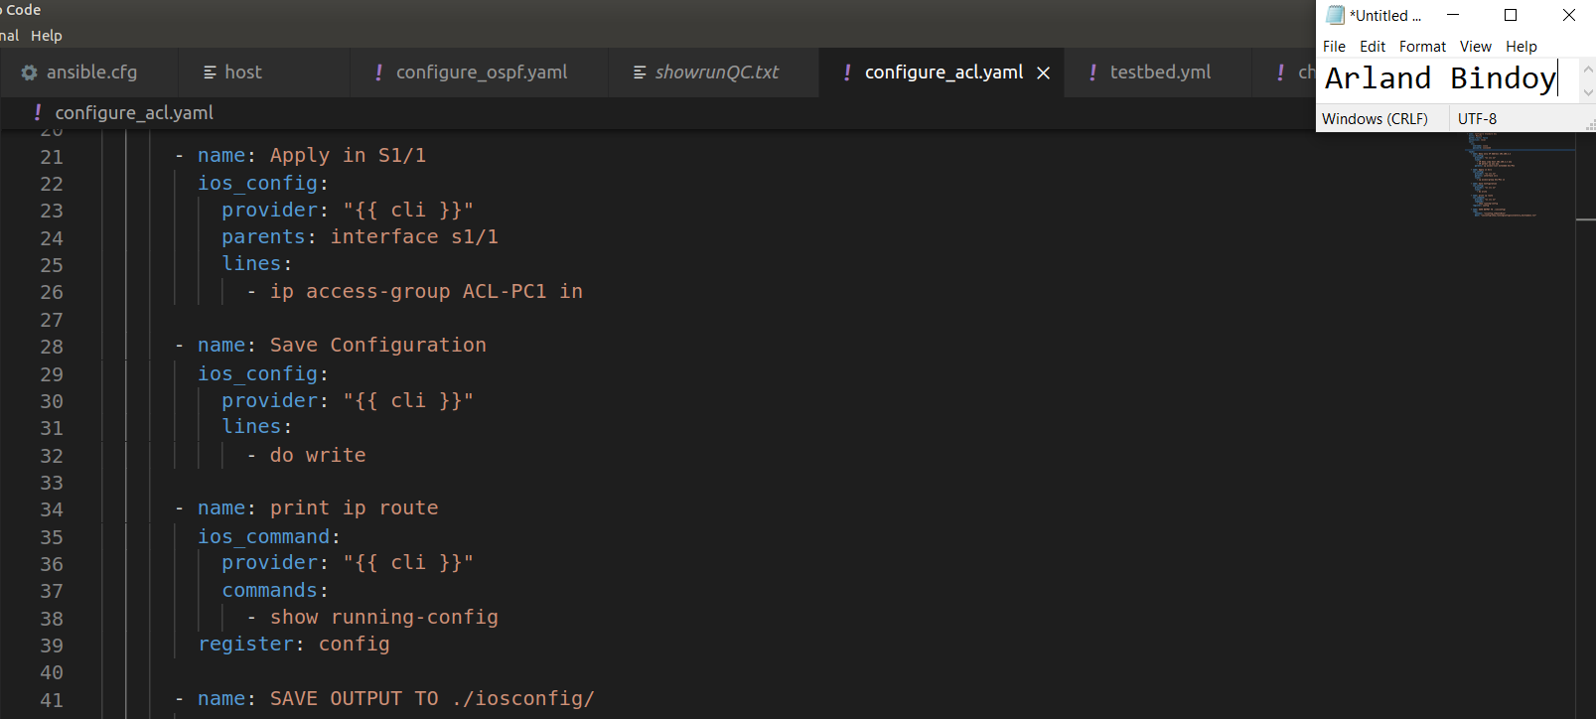

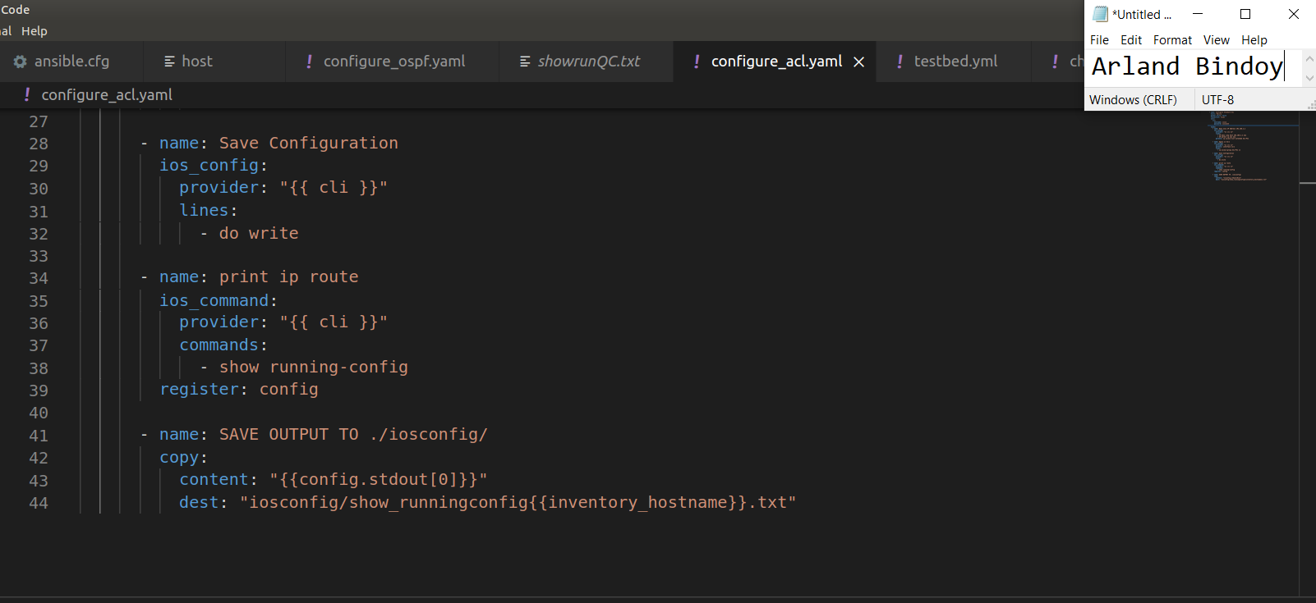

**Output of acl yaml**

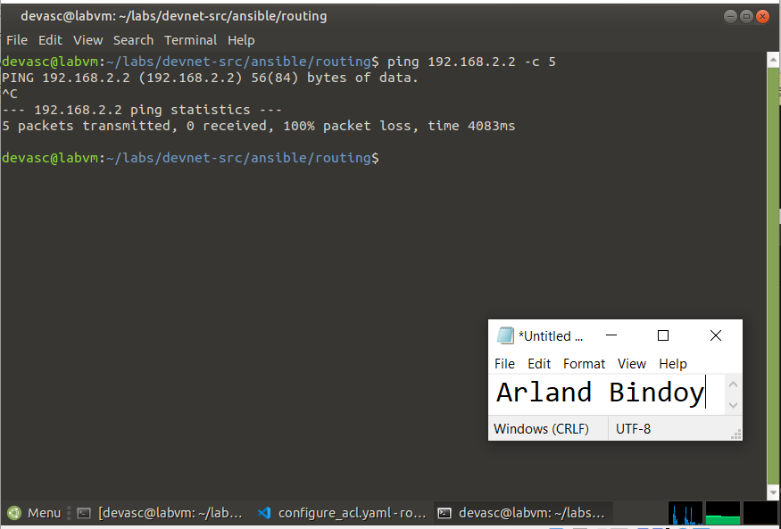

**Pyats**

**testbed.yml**

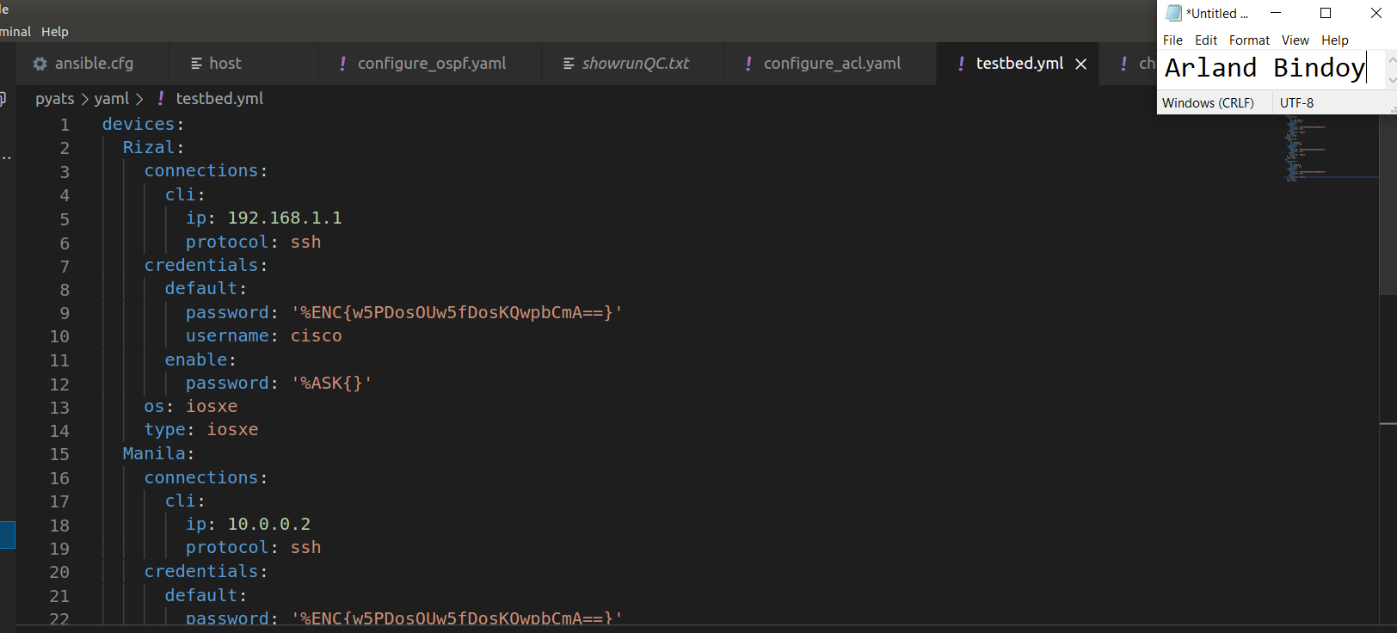

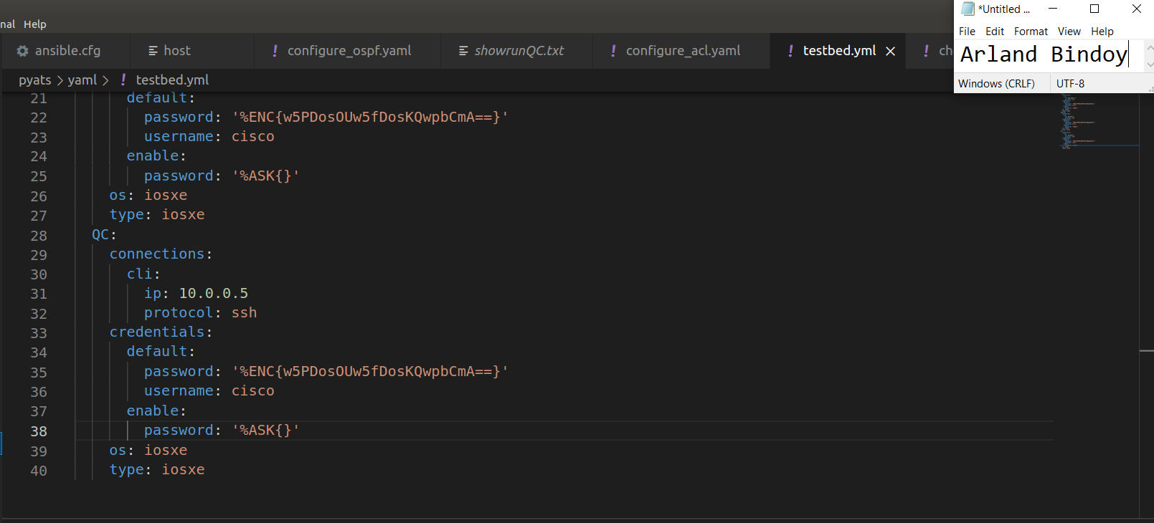

**genie parse "show ip interface brief" --testbed-file yaml/testbed.yml**

**Rizal**

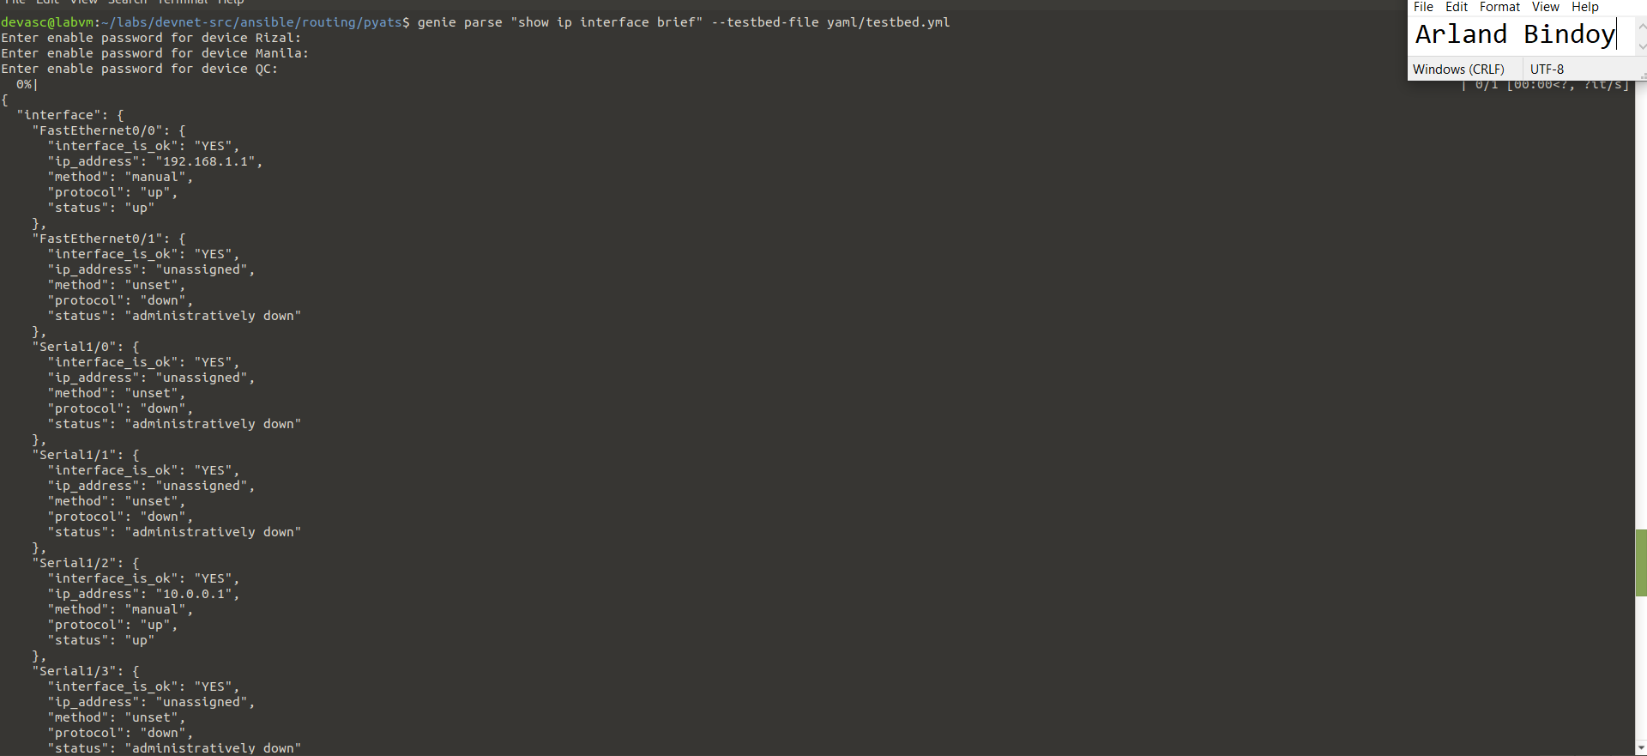

**Manila**

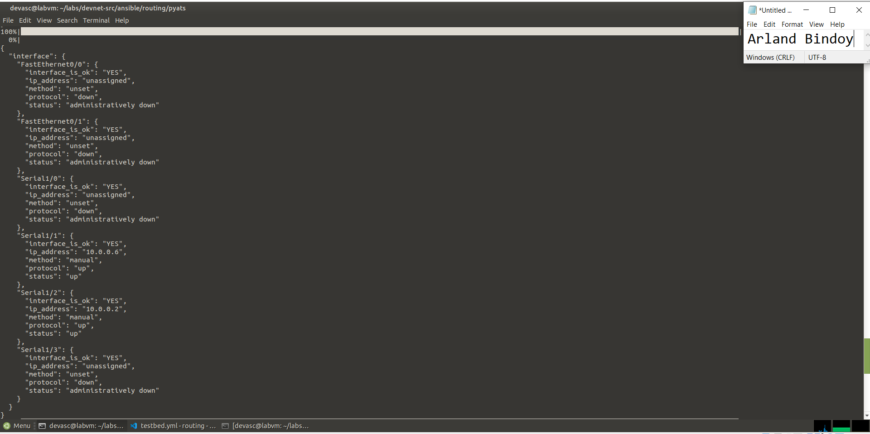

**QC**

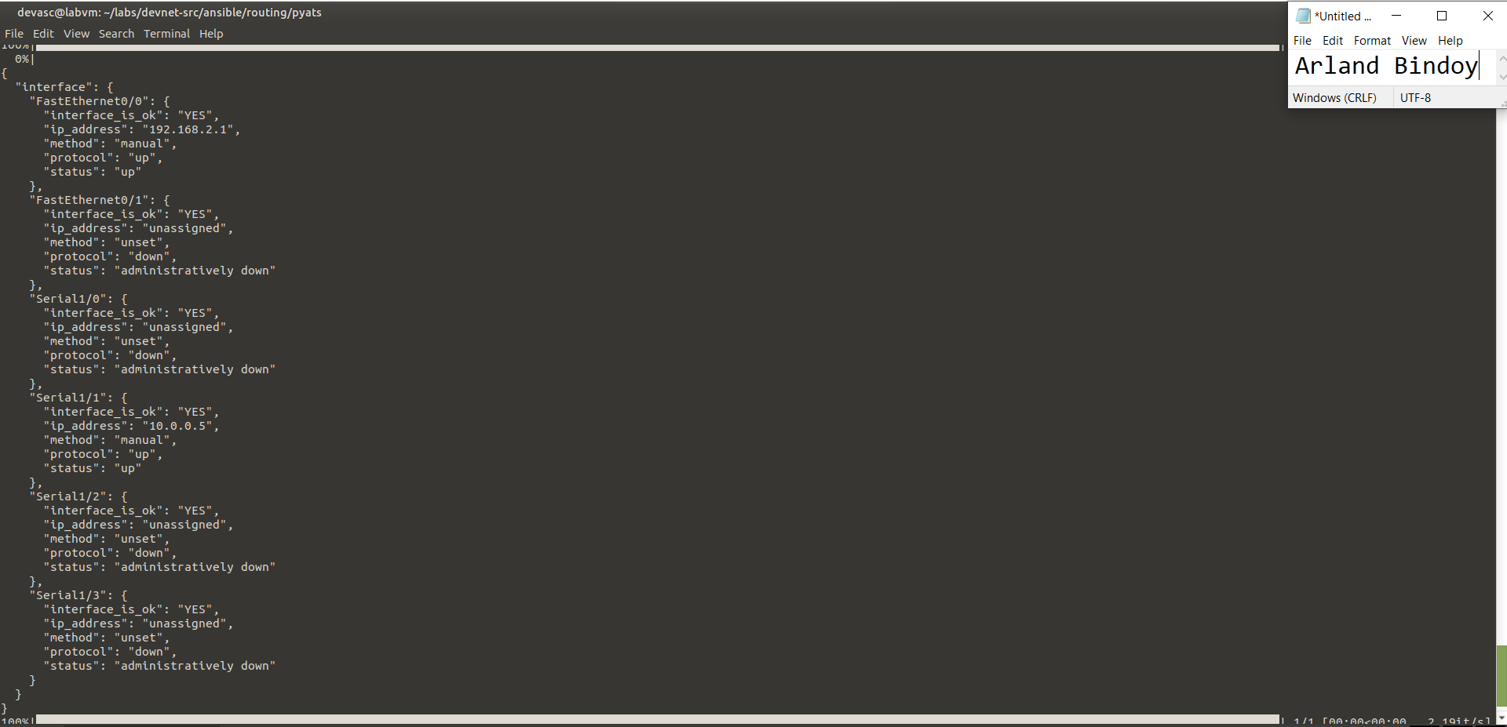

**genie parse "show ip ospf neighbor" --testbed-file yaml/testbed.yml**

**Rizal**

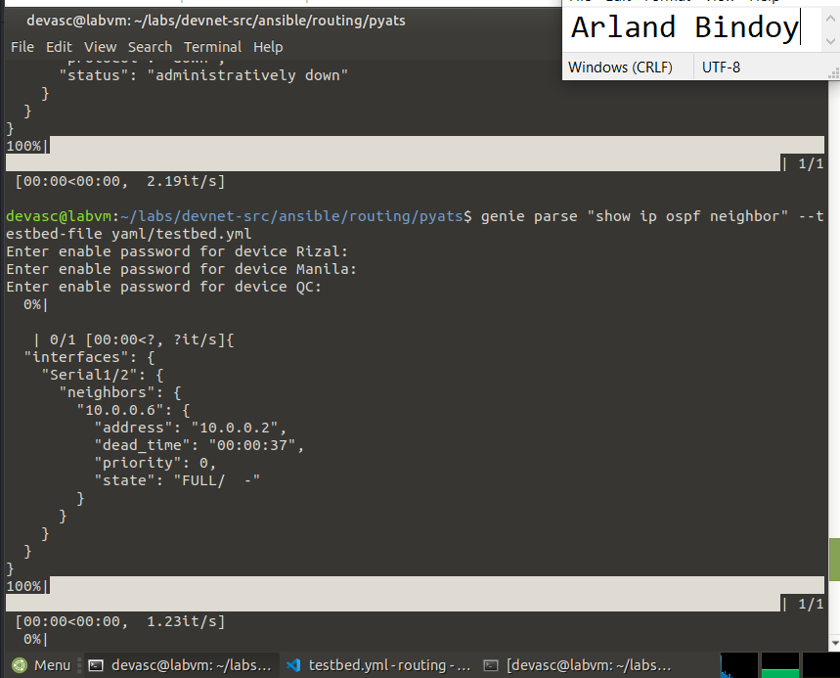

**Manila**

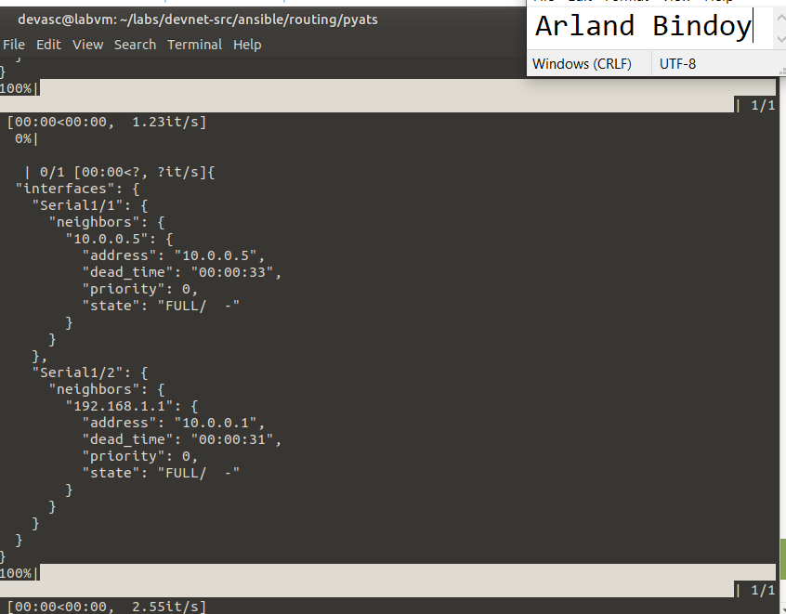

**QC**

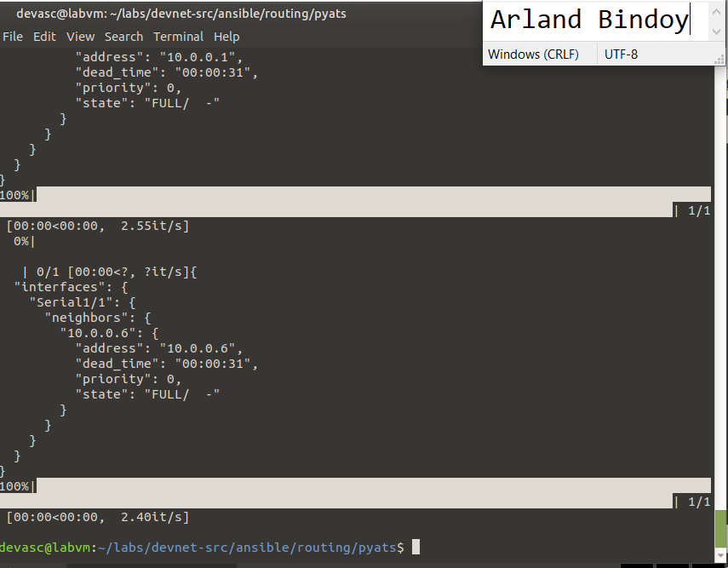

**gdrive link of Video Simulation:**

[**https://drive.google.com/file/d/1y99U7JSE9M0ka2f-KIkYrXplRRez0Gsu/view?usp=sharing**](https://drive.google.com/file/d/1y99U7JSE9M0ka2f-KIkYrXplRRez0Gsu/view?usp=sharing)

**gdrive link of Documentation:**

[**https://docs.google.com/document/d/1_y0G0_-FW2DxsnVg6_uo2v78kFusyphh/edit?usp=sharing&ouid=101608937587523280714&rtpof=true&sd=true**](https://docs.google.com/document/d/1_y0G0_-FW2DxsnVg6_uo2v78kFusyphh/edit?usp=sharing&ouid=101608937587523280714&rtpof=true&sd=true)

**gdrive link of GNS3 topology**

[**https://drive.google.com/file/d/1gaM4AeQqCXl5pHwDEiibyJkZpDIJXnvj/view?usp=sharing**](https://drive.google.com/file/d/1gaM4AeQqCXl5pHwDEiibyJkZpDIJXnvj/view?usp=sharing)

**Github link:**

[**https://github.com/arlandbindoy/FINAL-CASE-STUDY**](https://github.com/arlandbindoy/FINAL-CASE-STUDY)

**“I affirm that I have not given or received any unauthorized help on this assignment, and that this work is my own.”**